PROJECT DOCUMENTATION
REVIEW – 1

AI-CODE REVIEW USING LARGE LANGUAGE MODELS

Team Number :10
s.no | Name | Roll No
1 | P.PRANATHI | 2420030043
2 | E.MAHATHI | 2420030093
3 | B.SRIHITHA | 2420030099


Problem Statement:
Software code review is essential for detecting bugs, security vulnerabilities, and maintainability issues, but manual review is time-consuming and depends heavily on reviewer expertise. Traditional static analyzers provide deterministic rule-based findings but lack semantic and repository-level context. Conversely, LLM-based reviewers can understand and explain code but may generate false positives or unsupported suggestions when relevant contextual information is missing. Recent studies continue to identify insufficient context, false positives, trust, and evaluation reliability as important challenges in LLM-assisted code review.
Therefore, there is a need for a hybrid, context-aware automated code review framework that combines deterministic static analysis with semantic retrieval and LLM-based reasoning.
Motivation :
- Manual code reviews consume significant developer time.
- Static tools lack semantic and repository context.
- LLMs may generate unsupported review suggestions.
- Similar historical code can provide useful evidence.
- Hybrid analysis can improve review reliability.

Objectives :
Primary Objective :
To develop a hybrid context-aware automated code review framework that integrates static analysis, semantic code retrieval, Retrieval-Augmented Generation, and a code-specialized LLM.
Specific Objectives
- To Develop multi-language code analysis for Python, Java, and JavaScript.
- To Integrate language-specific static analyzers to detect deterministic rule-based issues.
- To Generate semantic code embeddings using CodeBERT for contextual retrieval.
- To Build a FAISS-based vector database for efficient similar-code search.
- To Implement a RAG pipeline using CodeSearchNet and selected GitHub repositories.
- To Construct structured prompts containing code, issues, and retrieved context.
- To Use CodeLlama to generate contextual reviews and suggested fixes.
- To Provide explainable severity-ranked recommendations with supporting evidence.
- To Evaluate retrieval and review performance using appropriate benchmark and repository data.

What Model/Framework Are We Building?
You are building a Hybrid Context-Aware Code Review Framework:
Hybrid Context-Aware Code Review Framework

Static Analysis
+
Semantic Code Retrieval
+
Retrieval-Augmented Generation
+
Code-Specialized LLM
↓
Explainable Automated Code Review
Framework Components
Layer 1 — Static Analysis
Python → Pylint
Java → PMD
JavaScript → ESLint
Addresses: deterministic bugs, rule violations, and code-quality issues.

Layer 2 — Semantic Retrieval
Code → CodeBERT → Embedding → FAISS
Addresses: lack of relevant contextual knowledge.

Layer 3 — RAG
Query Code → Retrieve Similar Code → Context
Addresses: generic or unsupported LLM responses.

Layer 4 — Prompt Engineering
Source Code
+ Static Findings
+ Retrieved Context
+ Review Instructions
Addresses: unstructured and inconsistent LLM input.

Layer 5 — CodeLlama
Structured Prompt → CodeLlama → Review
Addresses: explanation, reasoning, and suggested fixes.

Layer 6 — Explainable Output
Issue
Explanation
Severity
Suggested Fix
Evidence
Confidence Estimate

Literature Survey:
No. | Research Paper | Model / Method | Outcome | Limitations | Dataset Used + Link
1 | AI-powered Code Review with LLMs: Early Results (2024) | GPT-4-based LLM AI-agent framework | Detects bugs, code smells, risks, and improvement opportunities | Early-stage results; no clearly released benchmark dataset identified | Large code repositories with reviews, bug reports, and best-practice documentation; public dataset link not specified (arXiv)
2 | An Insight into Security Code Review with LLMs: Capabilities, Obstacles, and Influential Factors (2024) | Six LLMs; GPT-4 performed best with CWE context | LLMs showed strong potential for security defect review | Verbose responses; limited capability; performance affected by code length and context | Security code-review benchmark/data used in the study; CWE reference information; no standalone dataset link clearly provided in the paper metadata found (Papers with Code)
3 | Evaluating Source Code Quality with Large Language Models: a Comparative Study (2024) | GPT-3.5 Turbo and GPT-4o vs. SonarQube | GPT-3.5 correlated with SonarQube maintainability; LLM can assess some quality aspects | Java-only; two OSS projects; output/model-version variability; context-window and cost limitations | Quarkus + Shattered Pixel Dungeon; 1,641 Java classes. Supplementary dataset/software (DOI.org)
4 | Combining Large Language Models with Static Analyzers for Code Review Generation (2025) | DAT + RAG + NCO; hybrid KBS + LLM approach | Hybrid approaches improved relevance, completeness, and review quality; RAG was especially effective | Static analyzers can produce false positives; LLM output may be irrelevant for complex changes | Real-world code-review dataset and released artifacts. Zenodo dataset (arXiv)
5 | CodeAgent: Autonomous Communicative Agents for Code Review (2024) | Multi-agent LLM system with supervisory QA-Checker | Achieved strong results for inconsistency, vulnerability, style, and revision tasks | Multi-agent workflow increases architectural complexity and computational overhead | Public code and data released. CodeAgent project (arXiv)
6 | Fine-tuning and Prompt Engineering for LLMs-Based Code Review Automation (2024) | Fine-tuned LLMs + prompt engineering | Demonstrates that prompting and fine-tuning can improve automated review/refinement | Requires careful task-specific data and prompt/model configuration | CodeReviewer, Tufano, and D-ACT datasets. CodeReviewer resources (ScienceDirect)
7 | Automating Code Review Activities by Large-Scale Pre-training (2022) | CodeReviewer | Outperformed earlier methods on quality estimation, comment generation, and code refinement | Requires specialized pre-training and large-scale review data | CodeReviewer benchmark: Diff Quality Estimation, Comment Generation, Code Refinement. Zenodo dataset (arXiv)
8 | Code Review Automation using Retrieval Augmented Generation (2025) | RARe: Retrieval-Augmented Reviewer | Improved review relevance and outperformed baselines on two benchmark datasets | Performance depends strongly on retrieval quality and available external knowledge | Two benchmark datasets used for evaluation; see paper for exact dataset details (arXiv)
9 | LAURA: Enhancing Code Review Generation with Context-Enriched Retrieval-Augmented LLM (2025) | LAURA + ChatGPT-4o / DeepSeek V3 | Context augmentation and review-exemplar retrieval improved review usefulness | Requires high-quality contextual and historical review data; context collection adds complexity | Authors' dataset: 301,256 diff-comment-info records from 1,807 GitHub projects. Paper PDF (arXiv)
10 | Automated Code Review Using Large Language Models with Symbolic Reasoning (2025) | LLM + symbolic reasoning + prompting; compared CodeT5, CodeBERT, GraphCodeBERT | Hybrid reasoning improved accuracy and efficiency of automated review | Added reasoning stages increase pipeline complexity; evaluation is task-dependent | CodeXGLUE. CodeXGLUE (arXiv)

Research Gap Identification:

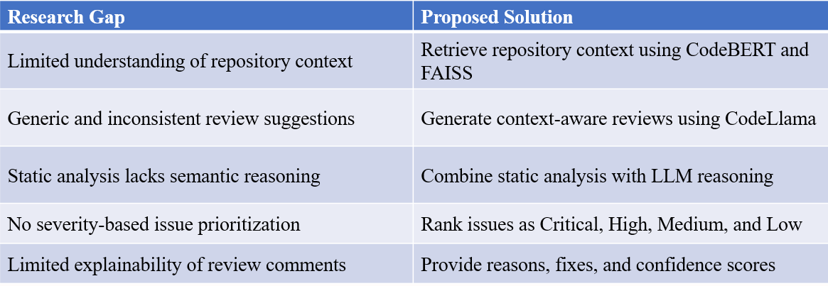

Innovation and Creativity:
Innovation
- Repository-aware code review using FAISS-based RAG.
- Hybrid integration of CodeLlama and static analysis.
- Intelligent retrieval of similar code before review.
- Context-aware code review with explainable suggestions.
- Unified review report with prioritized issue severity.

Creativity
- Simulates expert developer review workflow.
- Combines rule-based and AI-driven analysis.
- Supports Python, Java, and JavaScript.
- Generates developer-friendly review explanations.
- Modular architecture for future expansion.
Novelty
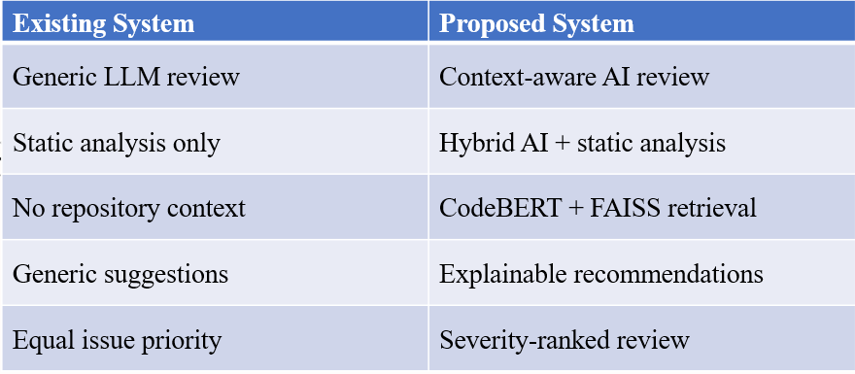
Key Contribution
- Hybrid AI-powered code review framework.
- CodeBERT-based semantic code retrieval.
- Repository-aware contextual review generation.
- Explainable and severity-ranked suggestions.
- Multi-language support for three languages.

FEASIBILITY ANALYSIS
Technical Feasibility
- Open-source AI models and libraries available.
- Supports Python, Java, and JavaScript.
- Efficient retrieval using CodeBERT and FAISS.
- Easy integration with static analysis tools.
- Achievable within the proposed timeline.
Economic Feasibility
- Uses open-source technologies.
- No expensive model training required.
- Low development and deployment cost.
Operational Feasibility
- User-friendly Streamlit interface.
- Easy integration into developer workflow.
- Modular and scalable architecture.
Time Feasibility
- Prototype completed within 4 weeks.
- Based on existing AI and RAG technologies.

PROJECT PLAN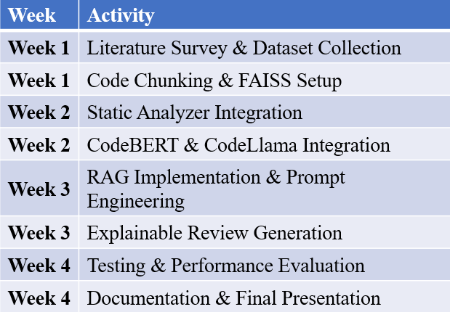
Expected Outcomes
- Automate code review for Python, Java, and JavaScript.
- Improve code quality through context-aware analysis.
- Generate accurate and explainable review suggestions.
- Prioritize issues based on severity levels.
- Reduce manual code review effort and time.
- Enhance developer productivity and code maintainability.
Provide a scalable framework for future language support.

PROPOSED ARCHITECTURE/METHODOLOGY
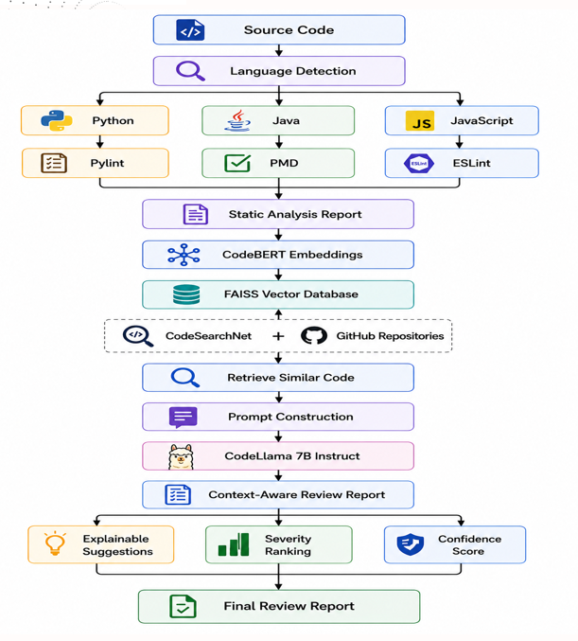
Workflow:
- Upload source code.
- Detect programming language.
- Perform static code analysis.
- Generate CodeBERT embeddings.
- Retrieve similar code using FAISS.
- Build contextual prompt.
- Generate review using CodeLlama.
Produce explainable review report
How Each Dataset Fits Into Our Workflow?
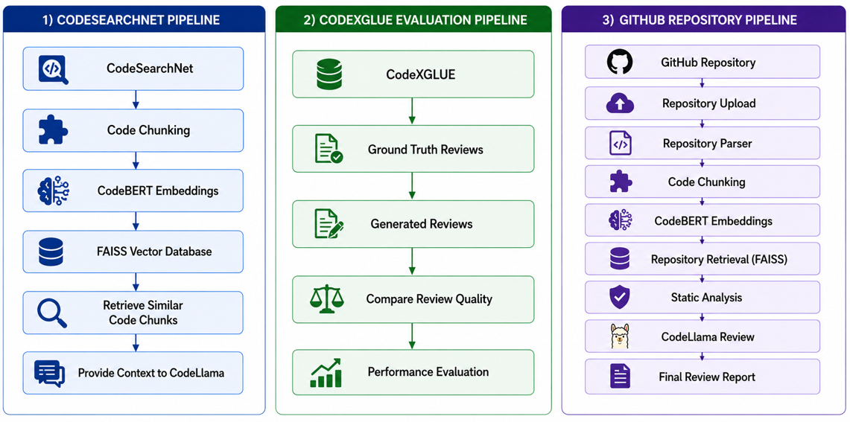

REFERENCES:
- AI-powered Code Review with LLMs: Early Results (2024)
- An Insight into Security Code Review with LLMs (2024)
- Evaluating Source Code Quality with LLMs (2024)
- Combining LLMs with Static Analyzers for Code Review Generation (2025)
- CodeAgent (2024)
- Fine-tuning and Prompt Engineering for LLM-Based Code Review (2024)
- Automating Code Review Activities by Large-Scale Pre-training (2022)
- Code Review Automation using Retrieval-Augmented Generation (2025)
- LAURA: Context-Enriched Retrieval-Augmented LLM (2025)
- Automated Code Review Using LLMs with Symbolic Reasoning (2025)

